MSML606 Extra Credit Project 2 Proposal - Rachel Bubeck

- Problem: I will be solving the Single-Pair Shortest Path Problem. This problem takes a non-negative weighted undirected graph and finds the shortest path from one specific vertex in the graph to another specific vertex. Some applications include GPS routes, delivery optimizations for packages/mail, and social networks (degrees of separation).
- Dataset: 500 CITIES DISTANCE DATASET : The dataset I plan to use is a 500 cities distance dataset on Kaggle, which contains three columns for 500 cities: “From”, “To”, and “Distance”. Below is a screenshot of the dataset from Kaggle.
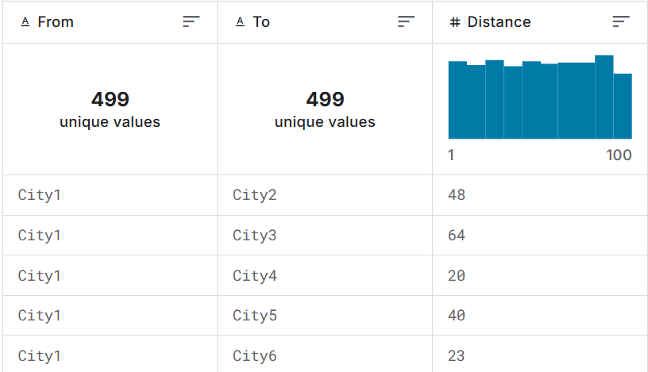
- Algorithm: I will be using Dijkstra’s Algorithm for this problem. This algorithm is iterative and greedy, and works by selecting the node with the smallest distance to the current vertex, updating that vertex’s neighbors, and marking it as visited. Dijkstra’s algorithm works well for finding the shortest path from one specific vertex to all other vertices in the graph, but for the single-pair shortest path problem, the algorithm will terminate early when the destination vertex is reached. The code for the algorithm will use a minimum heap priority queue to keep track of the distances and vertices. The algorithm’s time complexity is O((V+E)logV) where V = number of vertices and E = number of edges.

